Are You Programmed for Success?
What sets some people on the path to repeated failure, while others emerge from setbacks to achieve their goals?
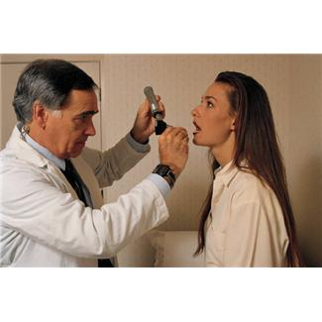I don’t profess to know the whole answer, but I do know that one thing that separates the winners from the losers is accountability to one’s self.
Accountability begins with a plan. As it’s been said before, “when you fail to plan, you plan to fail.” That’s true about fitness as well as in other areas of life. So—what’s your fitness plan? When will you fit fitness into your busy schedule? If you’re waiting for free time to miraculously appear on your calendar, it’s not going to happen. Plan your day around your workout, and everything else falls into place.
Accountability also means commitment, to yourself and to others. When you commit to make a healthy start and Take Back Your Life, you have some housekeeping to do. Start off with a visit to your physician to get the go-ahead for increased physical activity. Make a commitment on your calendar to keep your workout time sacred, no matter what else comes up. Set goals for how often you’ll work out, how much weight you want to lose, or an endurance goal like training to run a 5K or marathon. Once you have a goal in mind, it’s easier to stay on track because you’re working toward something tangible.
Accountability also means trying to get to the heart of what ails you. If you’re carrying around a lot of emotional baggage from a tough childhood or a bad marriage or a rough life, get into counseling and clean house. That kind of stuff is like poison, and it will hold you back in every part of your life until you deal with it. If you are struggling with illness or a chronic condition, get to the root of it. Go see a doctor, and if you don’t get an answer that solves the problem, go see as many doctors or medical practitioners as it takes. If all you get are prescriptions for pills, keep digging until you get someone who will help you understand the ways lifestyle, genetics, environment and nutrition contribute to your situation. Pills can help, but they’re usually not the whole answer – It’s a Band-Aid! And what you need is to get to the roots or just like weeds things multiply and become more complicated.
The last piece of accountability is taking action. Planning is just the beginning. You have to actually put your plan into action. I know so many people who are going to accomplish big things—someday. Folks, “someday” never comes unless you take action. So get going! Make an appointment with yourself today to work out. Make appointments with your doctors, counselors or practitioners to get your health in order. Then get out of your chair and start moving!

