The House that Atlas Built
It’s no coincidence that modern strength training got its start at the end of the 1920s, when a growing number of Americans had moved off the farm and into the city. Farming came with its own built-in workout that lasted from dawn until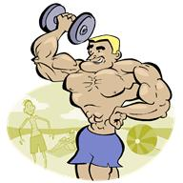 dusk. But city dwellers were at risk of being too thin from lack of exercise and poor nutrition. Then a young man named Charles Atlas, the original “97-pound weakling” created a system of isometrics and weightlifting that transformed him into both an icon and a very rich (and muscular) man.
The 1940s sent America’s men off to war, where they got their cardio in basic training and jumping jacks and their strength training hiking with forty-pound packs. When the war ended, many men were just as glad to leave “calisthenics” behind along with their Army boots. While farm wives and women in factories and hard labor jobs got their workout at work, suburban women shied away from exercise fearing that it would give them bulky muscles and be “unfeminine.”
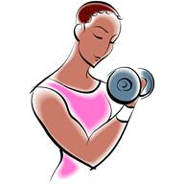Weight lifting and strength training remained largely a man’s world until the 1980s, when fitness centers replaced sweaty gyms and welcomed women with upbeat music, cross-training classes and Nautilus machines that took the fear and grunge out of the workout. As working out became more mainstream, people who had never been “athletic” began to find their way into fitness centers that welcomed those who weren’t bodybuilders or jocks.
Machines like the Nautilus and Cybex trainers helped people who were new to strength training get used to working out without intimidating free weights. They also made it easier for people who were recovering from injuries to ease into workouts without doing damage. At the same time, media images of women began to change. Movie audiences began to see actresses look buff AND beautiful (remember Linda Hamilton in Terminator?) and all of a sudden, muscles were sexy.
We’ve come a long way since Charles Atlas stopped bullies from kicking sand in his face and taught a generation of skinny guys how to bulk up. Today’s strength training has something for everyone, from total beginner to seasoned athlete. Women and men now feel equally welcome in today’s gyms, and programs like my Take Back Your Life system that encourages those who have never used hand-held weights or resistance bands to step up the challenge.
If you’ve been holding back from giving strength training a try, go for it! Get fit, get healthy and get going!

Here’s a link for more resources about strength training if you want to read on: http://en.wikipedia.org/wiki/Strength_training

