Your Food Choices Matter!
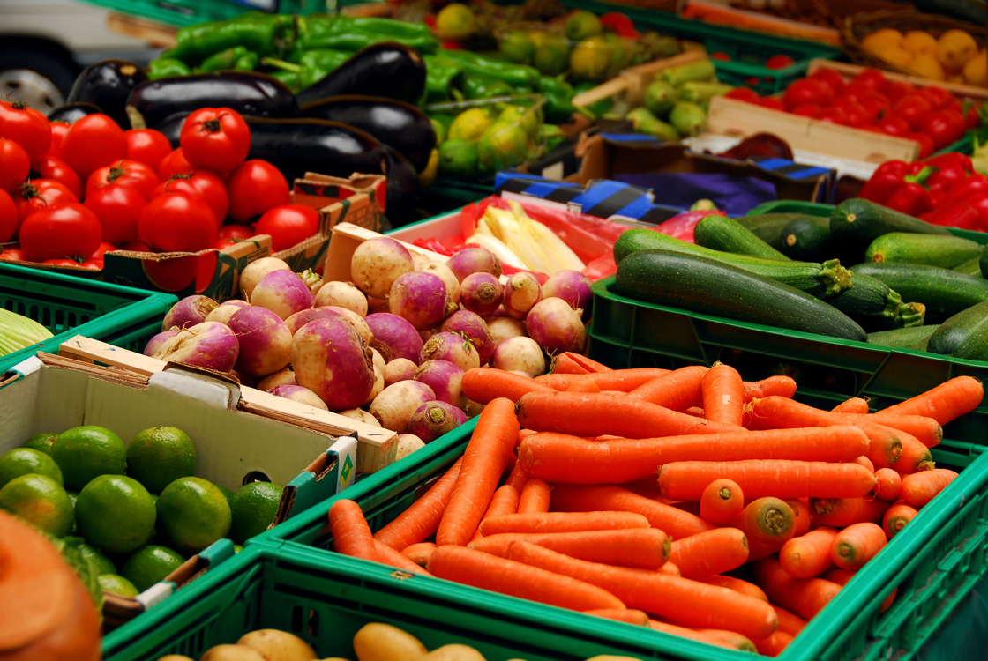Think that you can eat anything so long as you work out? Think again. Even if you’re pretty close to your ideal weight, your food choices affect your body, your brain, and the world around you. It’s not only true that “you are what you eat,” but it’s also true that how we eat affects our future health, our families, and our communities.
First off, let’s talk about food allergies. Many people don’t find out until adulthood that they are lactose-intolerant (milk allergy) or gluten-intolerant (wheat products). For many people, the quest to figure out what’s wrong with them has led them to a variety of doctors and through many unnecessary procedures before zoning into the idea of a food allergy. Just because you didn’t have allergies, as a kid doesn’t mean that you will never have allergies. Many allergies are acquired later in life, as unfair as that seems.
If you start to have strange symptoms, ask your doctor if they could be food allergies. Some food-related symptoms include serious digestive problems, diarrhea, rashes, bloating, swollen and painful joints, difficulty breathing and headaches. Try to remember what you ate just before the symptoms occurred. Some common food culprits are milk products, products which include wheat (it’s in more things than you might realize), seafood and nuts.
Next, let’s discuss organic food. To be truly “organic”, food needs to be free of pesticides, artificial fertilizers, and chemicals as well as genetic modifications (GMO). True organic food is also processed to be free of chemical additives and preservatives. Labeling standards for organic foods are not consistent, so when in doubt, ask.
The goal with organic food is to reduce the impact of chemicals and petroleum-based products on your body and on the environment. Chemicals used in farming have been linked to allergies and other health-related issues, as well as fouling the water supply, contaminating the land and air, killing off harmless species of birds, animals and insects, and altering the food chain. Some people are especially sensitive to chemicals and have severe reactions to food additives, while other groups, such as children, pregnant women and people with compromised immune systems, are also at higher risk.
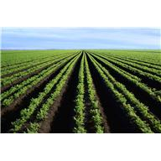Many people choose organic food because they want to know where there food has been, how it was grown (or raised), and what—exactly—is in it. Organic food is often also linked to the “local food” movement because preservative-free food needs to be consumed close to where it was raised to avoid spoilage and keep a fresh taste. Both movements have been good for small farmers, who have found niche markets growing organic food, selling produce by subscription to nearby households, and planting traditional “heirloom” varieties of plants that are naturally more disease and drought-resistant.
Others choose organic and cruelty-free meat because they object to the way animals are treated in large-scale commercial farming. “Factory” farming 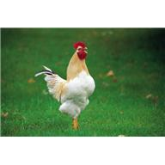often crowds animals into very small quarters with restricted movement and questionable cleanliness. Because of the crowded conditions, these farms often have to include antibiotics in their animal feed to keep down infection and disease. Some producers use steroids to fatten up animals more quickly. Whatever these animals eat goes into their milk or meat, and is consumed by the end user.
“Slow” food is a reaction to processed convenience foods and fast food. “Slow” food means going back to regional or traditional styles of cooking and preparation from raw foods rather than processed ingredients. The slow food movement also looks at fair wages and better working conditions for farmers and those who harvest the land, as well as sustainable agriculture methods. Both organic and slow food have encouraged people to think about the food3they purchase, order and consume as part of a bigger picture, and to see how their choices affect their neighbors, the economy and the environment as well as their own health.
To read more, here are some helpful links:
http://www.webmd.com/allergies/guide/wheat-allergy
http://www.allergy-details.com/gluten-free-diet/gluten-allergy-symptoms/
http://en.wikipedia.org/wiki/Organic_food
http://www.helpguide.org/life/organic_foods_pesticides_gmo.htmhttp://www.webmd.com/allergies/guide/wheat-allergyhttp://www.allergy-details.com/gluten-free-diet/gluten-allergy-symptoms/http://en.wikipedia.org/wiki/Organic_foodhttp://www.helpguide.org/life/organic_foods_pesticides_gmo.htmhttp://www.whfoo

